WEST HOLLYWOOD AREA SCHOOLS
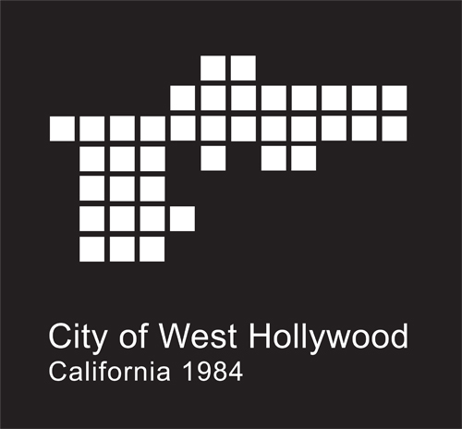

April 2022

Los Angeles Unified School District
333 S Beaudry Ave., Los Angeles, CA 90017
Phone: (213) 241-1000
Fax: (213) 241-8442
www.lausd.net

Elementary Schools

Gardner Street School  Karen Hollis, Principal  7450 Hawthorne Avenue  Los Angeles, CA 90046  (323) 876-4710  FAX: (323) 878-0954  Kholli1@lausd.net  www.gardnerstreetschool.org | Rosewood STEM Magnet, Urban Planning & Design  Linda Crowder, Principal  503 N. Croft Avenue  Los Angeles, CA 90046  (323) 651-0166  FAX: (323) 852-9653  Linda.Crowder@lausd.net  www.rosewoodelementary.org
Larchmont Charter School – Fairfax  Mersedeh Emrani, Principal  1265 N. Fairfax Ave.  West Hollywood, CA 90046  (323) 656-6418  FAX: (323) 656-6407  mersedeh.emrani@larchmontcharter.org  www.larchmontcharter.org/fairfax_program | Melrose Elementary Math Science Technology Magnet  Matthew Needleman, Principal  731 N. Detroit Street  Los Angeles, CA 90046  (323) 938-6275  FAX: (323) 938-4981  matthew.needleman@lausd.net  www.melrose-lausd-ca.schoolloop.com
Laurel Cinematic Arts and Creative Technologies  Lindsey Corcoran, Principal  925 N. Hayworth Avenue  Los Angeles, CA 90046  (323) 654-1930  FAX: (323) 656-5801  lmc0129@lausd.net  www.laurelspanschool-lausd-ca.schoolloop.com | West Hollywood Elementary School  Elizabeth Lehmann, Principal  970 N. Hammond Street  West Hollywood, CA 90069  (310) 274-5313  FAX: (310) 858-8139  Elizabeth.Lehmann@lausd.net  https://westhollywood-lausd-ca.schoolloop.com/

Middle Schools

Bancroft Middle School Performing Arts/STE(+A)M Magnets  Amy Diaz, Principal  929 N. Las Palmas Ave  Los Angeles, CA 90038  (323) 993-3400  FAX: (323) 461-8246  adiaz35@lausd.net  www.bancroftms-lausd-ca.schoolloop.com | * Laurel Span School  (see elementary school listing)
John Burroughs Middle School
Steve Martinez, Principal
600 S. McCadden Pl.
Los Angeles, CA 90005
(323) 549-5000
FAX: (323) 934-9051
sjm2585@lausd.net
www.burroughsms.org

High Schools

Fairfax High School  Dr. Lorraine Trollinger, Principal  7850 Melrose Avenue  Los Angeles, CA 90046  (323) 370-1200  FAX: (323) 651-5803  l.trollinger@lausd.net  www.fairfaxhs.org | West Hollywood Community Day School  Karen Cheval, Principal  1049 N. Fairfax Ave.  West Hollywood, CA 90046  (323) 654-4155  FAX: (323) 654-5635  kcc19004@lausd.net  www.whcds-lausd-ca.schoolloop.com
Walt Whitman High School
Simone Charles, Principal
7795 Rosewood Avenue
Los Angeles, CA 90036
(323) 651-0645
simone.charles@lausd.net
www.whitmanhs-lausd-ca.schoolloop.com

Private Schools

Center for Early Education  Damian Jones, Head of School  563 North Alfred Street  West Hollywood, CA 90048  Coed day school – preschool to Grade 6  (323) 651-0707  FAX: (323) 651-0860  JonesD@cee-school.org  www.centerforearlyeducation.org | Marlborough School  Priscilla Sands, Head of School  250 S. Rossmore Avenue  Los Angeles, CA 90004  Day school for girls – Grades 7-12  (323) 935-1147 Ext. 472  FAX: (323) 933-0542  priscilla.sands@marlborough.org  www.marlborough.org
Fountain Day School  Jane Dwinell, Principal  1128 N. Orange Grove  West Hollywood, CA 90046  Coed Preschool (2 yrs.) – K  (323) 654-8958  FAX: (323) 654-5214  fountaindayschool@gmail.com  www.fountaindayschool.com | Tree Academy for the Creative Arts, New Technology and Social Justice  Allison Curry, Interim Director of School  8628 Holloway Drive  West Hollywood, CA 90069  Coed day school – Grades 6-12  (424) 204-5165  www.treeacademy.org
Gindi Maimonedes Academy  Rabbi Aharon Wilk, Head of School  8511 Beverly Place  Los Angeles, CA 90048  Grades 2.5 years – 8th grade  (310) 659-2456 Ext. 2119  FAX: (310) 659-2865  rawilk@maimonidesla.com  www.maimonidesla.com | West Hwd. College Preparatory School  Elina Dvorskiy, Director  1317 N. Crescent Heights Blvd.  West Hollywood, CA 90046  Coed day school – preschool to Grade 12  (323) 822-7900  FAX: (323) 822-7999  edvorskiy@westhollywoodschool.com  www.westhollywoodschool.com
Adult Schools

Venice Skills Center
Melissa McCarthy
611 5th Ave, Venice, CA 90291
(310) 664-5888
www.mas6529@lausd.net
www.veniceskills.org
West Hollywood classes held at Plummer Park Community Center - 7377 Santa Monica Blvd.

