Community Meeting Room Access Instructions
A badge for access to the CMR can be checked out from anyone in the Arts and Economic Development Division (AED) on the 3rd Floor of City Hall.

If you get inquiries about renting the CMR by outside users, you can direct them to www.weho.org/libraryrooms . There are pictures, possible set-ups, AV specs, rental rates and instructions on this page. For internal City users all references are located on the ‘Arts & Economic Development Page’ of the intranet.

Instructions for unlocking door to the Community Meeting Room (CMR).
AED will check an access badge out to you for access to the room. The door will automatically open using the badge on the door sensor to the left of the door. Heavy room users already have access to the room via their employee ID badge, but if you are unsure if your badge is programming for this, you should check out a badge from AED for your meeting (but also test to see if your ID badge works is programmed for the door for future reference).

A day porter will meet you at the ‘meet time’ you indicated on your room set-up form to set the door in the proper position and check on you (see email at bottom of page). If you have any additional room needs this is the time to ask him/her regarding them.

Room Setup/Day Porter Meet Time
The room set-up form is the only form that facilities gets to determine how to set-up the room, and arrange what time the porter will check on you to make sure you don’t need anything else.

Preferentially you should submit your room setup two weeks in advance of your meeting to LibraryRooms@weho.org for communication to facilities; at the very latest it should be submitted at least 3 days prior to the meeting. If you do not send in a room set-up form at least 3 days before the event, facilities may not get the request in time, and you may have to set the room up yourself.

If you did request a set-up and the room wasn’t set-up, please let both lnolan@weho.org and libraryrooms@weho.org know.

Room Tech, Lightswitches, Blinds, & Projection Screen
You are responsible for attending a brief tech training if you plan to use the projector, and being self-sufficient in using the room. Tech training times are listed in the ‘City Users Guide to Booking Library Rooms’ on the AED intranet page.

All the light switches are on the wall (near the door to the kitchen). There is a very tiny dimmer switch that runs alongside the actual light button that can be used to adjust the brightness of the lights.

The blinds are controlled by the buttons on the wall near the phone on the wall. There are two sets of shades that can be independently controlled. There is also one light switch located here.

On the same wall as the lightswitches is a switch for the projection screen. The projection screen will also come down automatically when you activate it through the Touch Screen panel in the Equipment Rack.

Alarm
If the alarm goes off in the room, find the alarm panel which is located on the window side of the room directly across from the restroom hallway. To disarm simply put in the code and press enter.

Validation Machine
The Parking Validation machine is mounted on the west wall of the room. Place the bar code of the parking ticket under the red laser line until you hear a beep and see the message ‘Validation Successful’.

Mics and Batteries
Mics should be already set out by Facilities according to the room setup you have submitted. (If they are not, they can be found in the equipment closet nearest the window.) As you may be aware, the hand held mics in the Library CMR are each powered by two AA batteries. The pointer for use by presenters is powered by two AAA batteries.

Due to the continued popularity for booking the Library CMR, there are many days when multiple meetings occur in the same day. Facilities will continue to make every effort to have extra batteries on hand in the equipment closet for your meetings, however it is asked that everyone help conserve the battery life by turning off the mics when they are not in use.

The on/off switch is near the bottom of the mic. When the mic is off the display will be blank.

For those with recurring meetings in the CMR, you may want to prepare in advance by having a stash of extra batteries on hand for your particular meeting just in case.

Emergencies
If there is an emergency in the room such as the A/C not working, the alarm going off or a major tech malfunction, or door not functioning, you can contact Lisa Nolan at 323-774-8362 or Kevin Trudeau at 323-333-6698.

Checklist: Please check that the following are taken care of at the end of your meeting:
□ All mics are turned off. (The on/off switch is near the bottom of the mic. When the mic is off the display will be blank.)
□ Turn off lights
□ Make sure no one is left in the room or restrooms before locking up
□ Make sure all doors is locked. The Day porter will have set the door to automatically lock behind you. If there is an issue regarding this you can set the door to lock using the small key found in a black bag in the Rack PC area, or call Lisa Nolan.
Last updated 3/18/15 mc

Info on Door in CRM
Room Porter will set it in the appropriate position for your mtg, but this is in case you need the info.

From: Lisa Nolan
Sent: Friday, February 13, 2015 7:00 AM
Subject: CMR

Good Morning,

As a follow up to my email on Wednesday, I am attaching photos of the 2 key-switch positions that we will be utilizing, to avoid any confusion in the CMR.

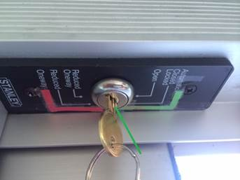

The photo above shows the position the key should be in when the door is in the “automatic” mode. I’ve exaggerated the green line to emphasize that there is a slight angle. This position will be used during meetings and events when the doors open and close from both sides during the meeting times only.

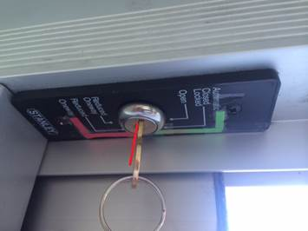

The photo above shows the position the key should be in when the door is in the “one-way” mode. Again, I have exaggerated the red line to emphasize the slight angle when in this position. When turned to “one-way,” the doors will automatically open from the inside going outside, but will restrict access from the outside in without an access card.

One thing I forgot to mention this morning is that I have purchased a step stool and it is in the media closet. There is also an extra key for the key-switch that we would like to keep in this closet also (see photo below.)

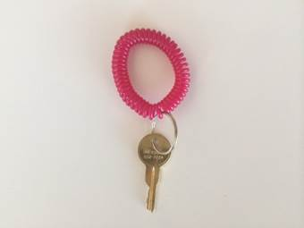

One last thing, I noticed several times in the past month, there have been signs taped to the windows of the CMR identifying the meeting. Due to the damage the tape can cause on the graffiti film, I purchased some acrylic sign holders and suction cups and those are in the media closet as well. Please feel free to use them at your convenience and return them to the closet when you are finished.

As always, if you have any questions, please feel free to contact me.

Thank you.

Lisa Nolan
Building Maintenance Supervisor
City of West Hollywood
Facilities and Field Services Division
Department of Public Works
Cell – (323) 774-8362
Office – (323) 848-6353

